PRACTICAL 2

NAME : R.SAMSHRITHA
CLUSTER 3 AND SECTION 7

TASK 1:

CODE IMPLEMENTATION AND EXECUTION:
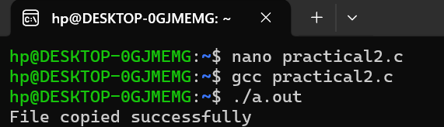
CONTENTS IN SOURCE.TXT:
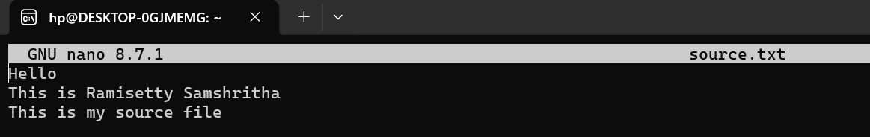

CONTENTS IN DESTINATION.TXT:
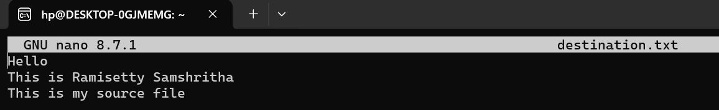

TASK 2:
